**SUDIKSHA KAUSHIK**

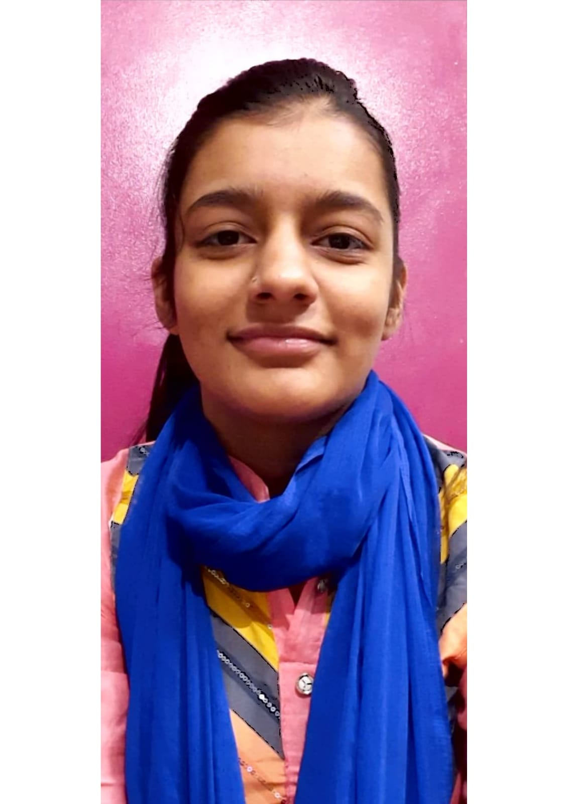aste your professional picture here

Holi chowk, Devli ● New Delhi-110062

[● sudiksha.kaushik_cs20@gla.ac.in](mailto:●%20sudiksha.kaushik_cs20@gla.ac.in) ● +91 7042870086

# EDUCATION

**Bachelor of Technology, *GLA University, Mathura*** (73.5 CGPA) 2020-2024

**Intermediate, Laxman Public School, Hauz Khas, New Delhi**(78%)2019-2020

**High School, St. Mary’s Public School, Sainik Farm, New Delhi**(81.3%)2017-2018

# INTERNSHIP EXPERIENCE_____________________________________________________________________________

**Job Oriented Value Added Course, GLA** **University** Jun 2022 – Jul 2022

* Website on Bakery Shop with the help of HTML, CSS and Javascript.

**Internshala**, Online May 2022 – Jul 2022

* Summer Training in programming with Python.

# PROJECTS

# 

*Group Leader and Supervisor*

* Created a website on a Bakery shop.
* Website on Adventure activities with the help of HTML, CSS, Javascript and PHP.

# SKILLS

**Technical**

* Java ( Intermediate )
* Data Structure and Algorithm ( Intermediate )
* C language ( Beginner )
* Web Development (Intermediate)

**Professional**

* Effective Analytical Skills
* Effective Communication Skills
* Leadership skills.
* Adaptability.

**Certifications**

* Infosys springboard python
* Programming with python training
* Data Structures and Algorithms
* Job Oriented Value Added Course on Web Development Bootcamp

# EXTRA/CO-CURRICULAR ACTIVITIES

* Coordinated SPARDHA Closing Ceremony ( Sports Event, GLA)
* Coordinated BRAINWAVES ( IEEE, GLA)
* Coordinated SRIJAN (Ninad Music Club, GLA)

**DECLARATION________________________________________________________________________________________**

I hereby declare that all the above mentioned information is true and correct to the best of my knowledge.